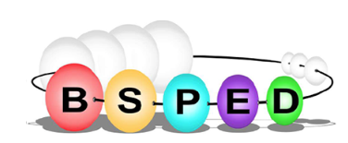
British Society for Paediatric
Endocrinology & Diabetes

Publications

1. Publication Summary

Overview
Total number of Publications
Total number of Peer Reviewed Publications
Total number of Senior Author Publications (first and last)
Total number of Citations
H index
Timescale this applies to

2. Publication list (10 most significant publications, including citation analysis)

